1. Create a cluster named 'redshift_hw9' (only use free tier)

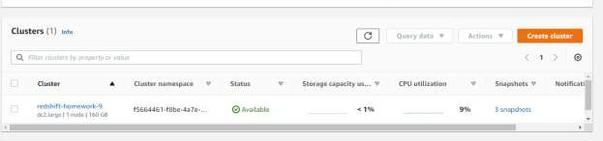

1. Create/Show the required IAM roles for the task.

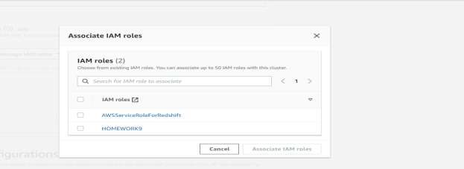

3Create an S3 bucket and load the tickitdb files.

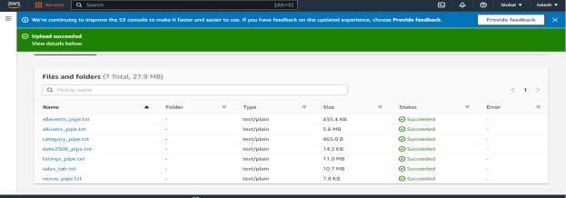

4.Create tables on your cluster. (CATEGORY table, DATE table, EVENT table, VENUE table, USERS table, LISTING table, SALES table)

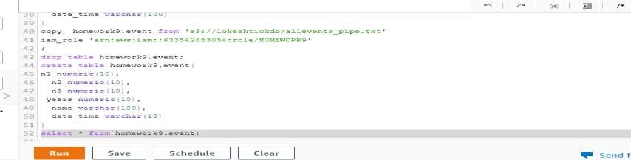

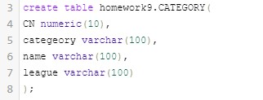

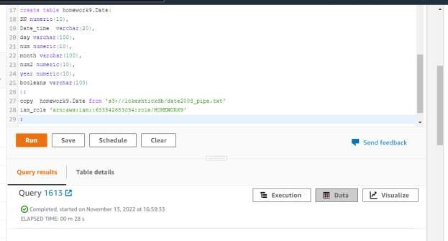

5. Copy the data from S3 to Redshift cluster 'redshift_hw9'.

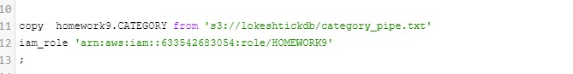

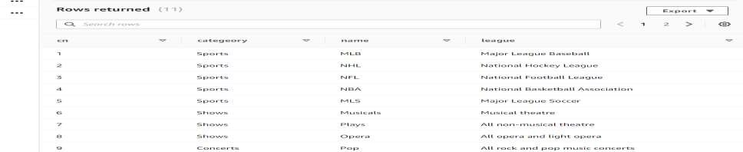

\

1. What are Database Querying Options available in Amazon Redshift?

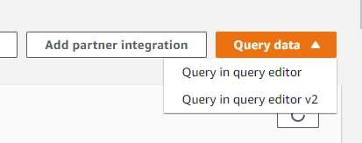

1. Delete the cluster 'redshift_hw9', IAM role and S3 bucket

